**Journey Through The Bible**

**Lazarus**

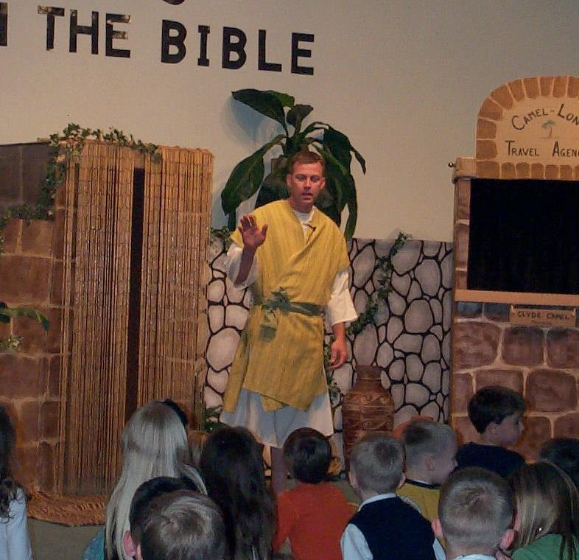

My name is Lazarus. I live in the small town of Bethany, not far from Jerusalem. My friend Jesus has many friends but he is especially close to my sisters, Mary and Martha, and to me. He often stays in our home when he visits Bethany. We look forward to his visits and feel it is a blessing to listen as he teaches us about the will of God, his Father.

One day I became very sick. I do not remember all that happened, but I have been told that my sisters did everything they could for me and our friends and neighbors in Bethany came to pray for me. My sisters were so worried they sent word to Jesus in Jerusalem that his friend Lazarus was sick. They knew that if Jesus came and prayed for me that God would make me well again.

After Jesus stayed two more days where he was he told his disciples, “Lazarus is sick, but I will go and awaken him.” His disciples told him that if Lazarus was sick sleep would be good for him. Jesus said “Lazarus is dead.”

By the time Jesus arrived in Bethany, I am told that I had been dead and buried in a tomb like a cave for four days. When Martha heard that Jesus was in Bethany she went to meet him. She said to him, “Lord, if you had been here, Lazarus would not have died.” Jesus asked if she believed in him. She told him that she believed he was the Christ, the Son of the Living God. He said, “He that believes on me will never die.”

When Mary heard that Jesus was there she went to meet him. All the people who were there to comfort them followed her. Mary said to Jesus, “Lord, if you had been here Lazarus would not have died.” Jesus was not pleased about that. Jesus asked where I was buried.

I am told that when Jesus saw the tomb where I was buried he wept. The people thought he was crying for the death of his friend but he was sad because Mary and his followers did not believe he could raise me from the grave after being dead four days.

Jesus asked them to remove the large stone from the front of the tomb. Then he cried to God with a loud voice.

“I know you hear me always but for the people here I speak so that they will believe that you sent me.” Then he said with a loud voice, “Lazarus, come forth.”

When I first awoke I did not know where I was and what was happening. Some one removed the cloth from my face and it looked like I was in a cave with Jesus, my sisters and a crowd of friends around me. I heard Jesus say

“unbind him and let him go.”

As they unwrapped the grave clothes from my body and I was able to sit up and I realized I was not sick anymore. I could see the expressions on the faces of the people around me as they believed that Jesus Christ was the son of God. My sisters and the crowd of people were thankful for this miracle that Jesus performed.

I watched as many in the crowd ran to tell others of the good news.

My story came from the book of John. Now I would like to ask you some questions about me. (Prepare several questions to ask the students.)

Scripture reading: John 11:1-44; 12:9, 10

**Memory Verse:** John 11:42

I said this, that they may believe that You sent Me.

